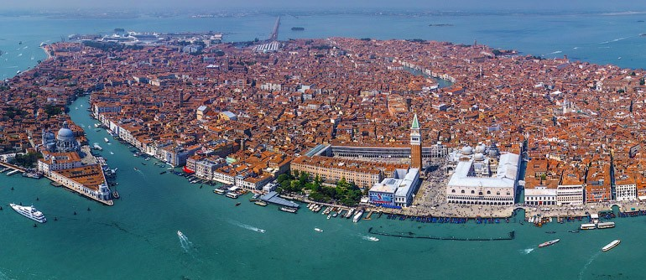

Venice is a small city, extremely concentrated, every corner, monument, Church or museum contains a piece of history, a tale, a way to say or a tradition, not to be counted all the news and events that daily the city offers to citizens and visitors.  
Surf into the contents of our pages, discover the history of Venice, museums, monuments, Churches, theatres, you will find all the curiosities and peculiarities  that make Venice a unique city, the way to say, feasts, international appointment as Carnival, the Redemption and the Historic regatta, as well as local happening, as brick a brack markets and amateurs regattas to make Venice so special.  
Discover also our suggestions to visit the city, itinerary (from the classics to the extravagant ones), bars, restaurants, hotels and shops.

HOTELS

# *Locanda Vivaldi*

C:\Users\Ray\Desktop\vivaldi.jpg

Relive the magic of ancient Venice and the splendour of its lagoon in the surroundings of the Locanda Vivaldi hotel, a historic dwelling of the composer Antonio Vivaldi, that has now been completely restructured and transformed into a small and charming hotel.

This small and refined boutique hotel, a pearl in the heart of Venice of dreams, art, culture and music will surprise you with its personality and with kindness and helpfulness of its staff.

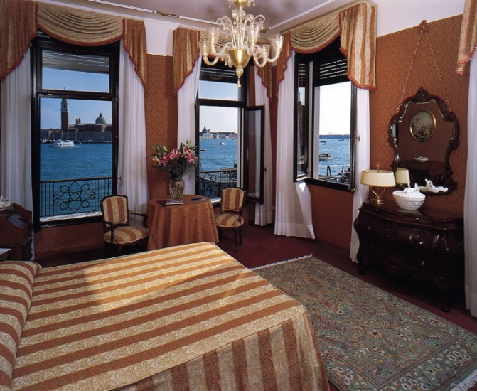

# *Hotel Santa Chiara*

C:\Users\Ray\Desktop\santachiara2.jpg

Situated in an ancient and more than 500 years old palace, the Santa Chiara Hotel is the only one in Venice which offers its guests the commodity of a private parking for the guests arriving by car or motorbike.

Professionalism of a great and modern hotel, together with the ancient and refined tradition of hospitality, make the Santa Chiara Hotel the ideal place to stay in while in Venice, and where cordiality, friendliness and helpfulness will help to satisfy any of your needs and discover the charm and the mystery of a city praised by writers and poets all over the world…

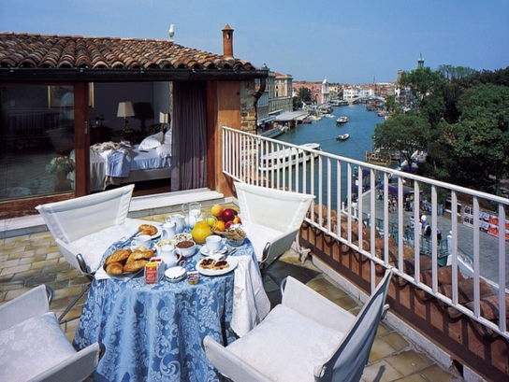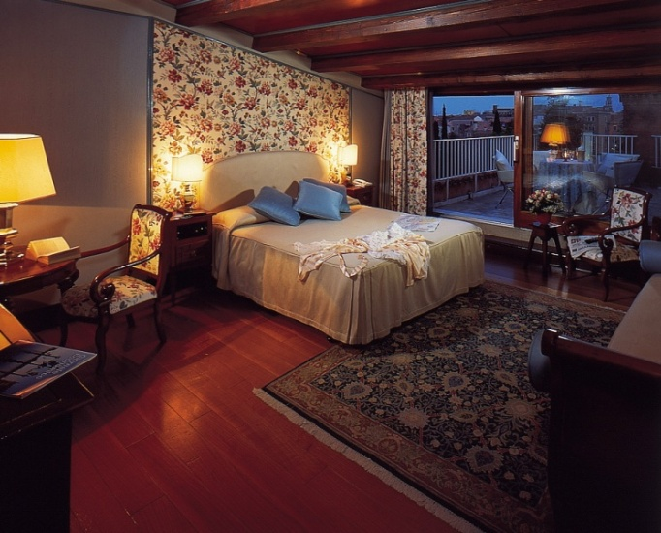

# *Hosteria Da Franz*

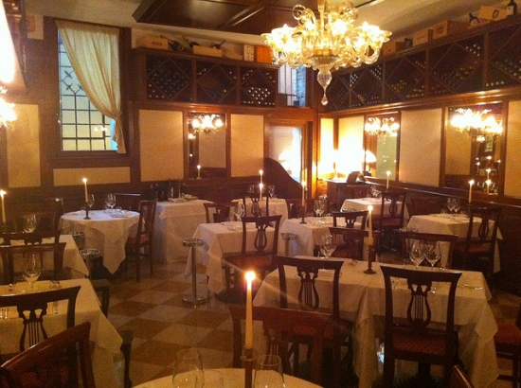

Restaurant "Hostaria da Franz" takes its name from Franz Habeler, a young Austro-Hungarian army soldier who adopted Venice as his home, served fish and wine he bought from local farmers and fishermen.

After 30 years in the original establishment in Biennale area the Gasparini family are transferred in a new place in Arsenale much more in center town but in the same time in a not tourist area.  
Today, Hostaria da Franz has become one of the most famous seafood restaurants in Venice, signaled by the best gastronomical guides, where chef Gianfranco and his son Maurizio prepare delicious freed seafood delicacies. The ambience is elegant and romantic,very high service level.  
Very big choice of traditional plates and some propose of the chef. Pasta,desserts and brad for the cheeses are home made. The wine list propose the best italian labels. It's pretty easy to come from St.Mark Square (5 min.) walking following Riva degli Schiavoni.  
We suggest to make your reservation especially for dinner.

**Hostaria Da Franz**

Castello, 3499

30122 Castello Venezia -Email: [info@hostariadafranz.com](mailto:info@hostariadafranz.com)

Ph. +39 (0)41. 5220861 Fax. +39 (0)41. 2419278

# *Da Fiore*

*Da Fiore*Chez Da Fiore Restaurant, synonymous of elegance and tradition, you can taste what is now considered lost...

...aromas and scents from a Venice who remain, here, unchanged.  
  
Mara Martin, an extraordinary Chef, is able to bewitch the Italian and foreign public, obtaining acknowledgments to world-wide level.  
  
Active and energic woman, devote to her cuisine care and love, typical of long time ago. In Mara’s  recipes and cuisine you will find the typical magic of Veneto area and in particular of Venice. Venice has been the joining point not only of the economics of East and West, but also of their culture and cuisine. For this reason the tradition of this place are so unique, and all these particularities relive in Mara’s hands! A precious art, tradition and innovation put together.   
  
Mara’s apprenticeship start when she was a child, in her grandmother’s kitchen, were the most part of the local banquets ware prepared. Observing she started to learn what will be later awarded with a Michelin Star.

Calle dello Scaleter - 2202 Venezia - Ph. +39 (0) 41 721308

# *Il Refolo*

C:\Users\Ray\Desktop\il-refolo.jpg

Refolo is the new youthful and alternative restaurant directed by Damiano Martin son of the owner of the restaurant da Fiore...

... This new meeting point, with its youth, nice and informalatmosphere, show itself not only as restaurant but as pizzeria or simple "cicheteria" (a kind of traditional venetian pub). Here you can taste good pizzas, refined and tasty dishes, different kind of cheese and wine and many other high quality things, that makes the name Martin like a guarantee mark.

**Il Réfolo**

Campiello del Piovan

Santa Croce 1459

30125 Venezia

Ph. +39 (0) 41 5240016

**Places to visit**

# *The Dogi Plalace and its secrets*

*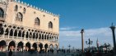***The Dogi Palace** represent **the symbol and the hart of the  political and administrative life of the Venetian Republic millenary history**. In the halls of the palace the Doge and the council took all the decision about Venice and its life. 

In 1797 the history of the winged lion republic changes dramatically ending under the French and Austrian domination until the annexing with the reign of Italy in 1866. Duriong this periods the palace become site of various offices and hosted as well the National Marciana Library.

**At the end of 17 century the Italian government restored the building**, all offices and institution were moved and the only one left and still present is the “ surveyor of ambient and architectonical establishment of Venice and lagoon. In December 1923 the Italian state entrust the management to Venetian Municipality that opened the palace as a museum and starting from 1996 the palace become part of **the Musei Civici Veneziani system.**

The dogi palace is **a masterpiece of gothic art structured** on a magnificent  stratification of elements, foundations dated 300/400 renaissance style cusps, and mannerism signs.

It counts three big parts: **the wing toward Saint Mark’s basin** that host the major council hall which is the oldest, **the wing toward the square**, former justice palace that host the poll hall, and finally **the renaissance wing** that host the Dogi residence and many government offices.  
The visitor entrance is under the archway of the 12th century façade in front of Saint Mark’ s basin, the ground floor host services for the public and the former doges kitchen host  periodic exhibitions and the opera museum, the opera was originally a sort of technical office assigned to the maintenance and restoration of the palace. the access is from the dogi palace courtyard there it is also the magnificen “ **Scala dei Giganti**” the stairs of the Giants the ancient Honour access **with the two enormous statue representing Mars and Neptune, sculptured by Jacopo Sansovino in 1565**, the journey continue on the upper halls where can be find the “ **Piano delle Logge**” with view on the rooms enriched by the “**Appartamento Ducale**“ the dogi’s apartements then the “**Stanze Istituzionali**” the institutional Halls, the visit ended on **the armoury and the prisons.**

The are also **secrets itinerary**not accessible with the standard journey, the secret itinerary offers a suggestive and interesting approach to the most secrets and particular rooms of the palace.  
It is necessary to book this visit with a specialized guide. Call center +39 041 5209070

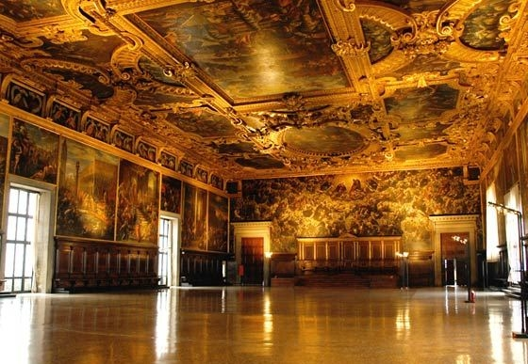

***Accademia Gallery Museum***

*Accademia Gallery Museum*

The **Accademia Museum** is part of  a complex including the church of Santa Maria della Carità, the homonymous Scuola Grande (the original entrance is now the main access to the museum) and the Monastery of the Canonici Lateranensi (the complex was in use until the beginning of the XIX century).

The **gallery**take its name from the **Accademia delle Belle Arti** (Art Accademy) who opened the building and shared the sites until few years ago (2004).  
  
The operas preserved inside the Gallery are many and of  inestimable value. Most of the painting comes from a period between the XIV and the XVIII century, tThe most important authors are **Carpaccio**, **Bellini**, **Tintoretto**, **Tiziano**. Also many sculptures and drawing can be admired, amongst them the vitruvian man by **Leonardo da Vinci**, exposed only few periods.

Initially the museum was operating as didactic and restoration of art operas centre.  
It had a key role for the artistic life of the city only after the fall of the Serenissima in 1797, the foundation saved many and many operas from the sack of  churches and palaces, without them all those could have scattered and lost around the world.

During the XVII century the whole structure was restored, this suited better  with the institution it represent, the church was subdivided in smaller room and new wings f the monastery were built, the Palladian style was then lost.  
Some important restoring works are on progress now to enlarge the exhibitions halls, however the gallery is open to the public and can be visited.  
  
The history of the whole complex begin way before of the Accademia delle Belle Arti. Church, Monastery and Scuola infact are dated XIII century, the Church and the monastery had a prosperous moment until 1630, then the decay culminated with the fall of the bell tower, the church was closed in 1806 after the suppression of the order of Canonici Lateranensi.  
The **Scuola**(one of the first Scuole Grandi of **Venice**) was hosted inside the monastery starting from 1260. before its site was in the church of San Leonardo in Giudecca.  
Thanks to the help of the Scuola the brotherhood grew until 1630. In that century the whole complex become bigger and the interiors embellished.  
Still possible to admire operas by **Titian**(the introduction of Maria to the Temple) and operas by Vivarini (the Madonna della Carità) on the hall of the School inn.

**Accademia Art Gallery**

Campo de la Carità, 1050  
30123 Venezia (Veneto)  
Tel +39 (0) 41 5200345

[[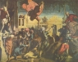](http://www.venice-tourism.com/images/stories/Museo_accademia2/jacopo_tintoretto_017.jpg)](http://www.venice-tourism.com/images/stories/Museo_accademia2/jacopo_tintoretto_017.jpg)[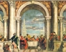](http://www.venice-tourism.com/images/stories/Museo_accademia2/paolo_veronese_007.jpg)[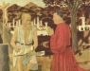](http://www.venice-tourism.com/images/stories/Museo_accademia2/piero_della_francesca_043.jpg)[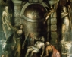](http://www.venice-tourism.com/images/stories/Museo_accademia2/tizian_053.jpg)[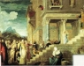](http://www.venice-tourism.com/images/stories/Museo_accademia2/tiziano_presentazione.jpg)

***Accademia Bridge***

*Accademia Bridge*The Accademia bridge was built during the Austrian dominium (1848-1866) as well the Scalzi bridge. Until then the only bridge spanning over the grand canal was the Rialto one.Many project were proposed, amongst them...

...also a tunnel, its purpose was not to trouble the passage of the boats (those times they had threes and sails) the final decision was to utilize the **Alfred Neville**Project, an Austrian engineer who projected also many suspended iron bridges. His idea was to build a single span more than 50 meters wide.  
Works ended in 1854, the 20th November , and it was named the charity bridge **Ponte della Carità**, name was taken from the homonymous **institute** there nearby **“The Charity”**.

It was a toll bridge !Neville projected also the train station bridge, both operas were disputed by the population because considered too industrial and not in harmony with **Venice** architecture.  
Few years later the bridge showed signs of  subsiding due to mistake on the foundation project. During the fascist regime the bridge was rebuilt quite fast, it was a wooden bridge instead of the iron one, the built takes only 37 days.  
This last project ended in 1933, was designed by **Eugenio Miozzi** and supposed to be temporary until a new one made in stone, lastly the decision to keep it in wood because of its sturdiness and reliability.

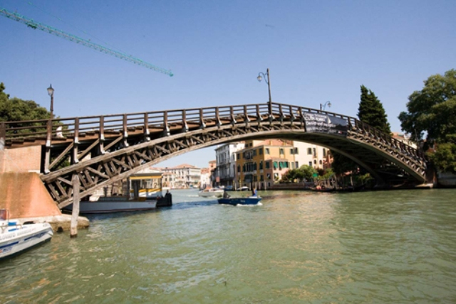

**Fun – Carnivals!**

# *The silent rowing parade*

*The silent rowing parade*Last appointment of the Carnival, Tuesday Feb. 2012 with **The Silent Rowing Parade**, a farewell to the Carnival, taken by a candle light rowing parade along the Grand Canal from Rialto Bridge to Saint Mark’s basin.

With gondolas and traditional rowing  boats wrapped into memories of a mysterious Venice, in the complete absence of engine boats, the already precious atmosphere will be enriched on his natural scenery by thousands of lights creating surreal Venice, palaces amongst light and shadows, a magic atmosphere of past epochs, creation of an unique and spectacular moment, suggestive an unrepeatable.

Once the parade get to Punta della Dogana  the Taurus, the symbolic allegory that will be moored for the entire Carnival on Saint Mark’s basin will be set on fire with fireworks, a pyrotechnic show greeting 2012 Carnival renewing the appointment for the next year!

# *The Flight of the Angel*

*The Flight of the Angel*The **Flight of the Angel**is an event usually held on Shrove Thursday of **Carnival**(grasso) this has its roots due to an event that happened in the mid 16th century. In those years, during various exihibitions, a Turkish acrobat did something that stupefied the Venetians.

With the only aid of a pole he walked on a rope from a boat tied in Riva degli Schiavoni to the top of [**St Mark’s Tower**](http://www.venice-tourism.com/en/Venice-Tourism/Sestiere-di-San-Marco/Saint-Mark-Bell-Tower.html)and then from the tower to the [**Doge’s Palace**](http://www.venice-tourism.com/en/Venice-Tourism/Sestiere-di-San-Marco/The-Doge-Palace.html) balcony, as a tribute to the doge.  
  
The exihibition changed its name and became “**The Flight of the Turk**”, it has been held every year with various changes, first it was made only by professional acrobats and lately by common people that wanted to show their ability and bravery.  
  
The exihibition name changed into “The Flight of the Angel” when for the first time an acrobat dressed with angel wings tied to a rope was let down the tower, at the end of the descent the doge himself gave the angel impersonator a gift.  
  
The event changed its name again into “**Volo della Colombina**” (“**The Flight of the dove**”) starting from 1759. In that year the acrobat dressed as the angel fell down over  the horrified crowd.  
Since then a wooden dove substitute the men.  
  
After the fall of the Republic the event was banned (as many other traditions) until recent times.  
  
Starting from 2001 “The flight of the Dove” become again “The Flight of the Angel” with the reintroduction of a real person instead of the wooden dove, staging the old ritual of the homage of the  sceptre to the Doge. This announced the beginning of the **Carnival of Venice**with a triumph of confetti and coloured air balloons. The event is now held on the week-end previous to Shrove Thursday and marks the beginning of the festivities.

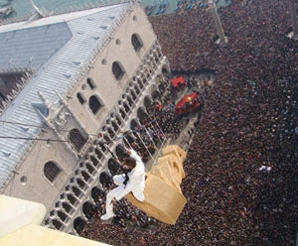

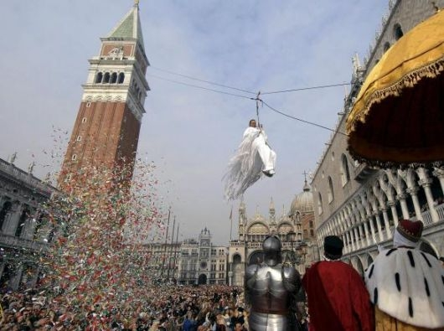

***Masks and Costumes***

*Masks and Costumes*In the past the **mask**was, and still is, the essence itself of the **Carnival**, by wearing masks and costumes it is possible to hide completely an identity with absolutely no reference to sex religion and age, social level or whatsoever.

This make you behave as use and habit of the impersonate character, a moment of escape from reality and  the platitude of everyday same old life.  
This is the reason why the most common salutation in use was “good morning mask”.  
  
The use of the mask in **Venice**start gradually developing from nothing bringing life to a rich activity of production and trade of masks and costumes.  
First news of this production are from 1271.  Specific tools where made to work the materials necessary to the mask production process, they were embellished with engraves, paintworks, laces and pearls.  
The job of “ Mascarer” (Mask Artisan) was officially registered with a special statute in 1946 and still conserved in the state Archive of Venice.

[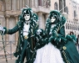](http://www.venice-tourism.com/images/stories/Maschere_e_costumi/venezia_carnevale_6.jpg)[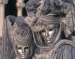](http://www.venice-tourism.com/images/stories/Maschere_e_costumi/carnevaleveneziaargento.jpg)[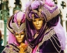](http://www.venice-tourism.com/images/stories/Maschere_e_costumi/italyvenicecarnevale.jpg)[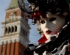](http://www.venice-tourism.com/images/stories/Maschere_e_costumi/maschera_e_campanile.jpg)

Starting from the XVIII century one of the most diffused mask was the “**Bauta**” or “Bautta” a very simple mask. The costume, wore  by men and women, consist on a with mask called “Larva” a three point hat and a black mantel.

The **mask**was popular also in some occasion out of the carnival, at the theatre or by people that wanted to be anonymous.  
  
It was possible to drink and eat easily due to the particular shape of this mask, no need to take it off.

Another quite in use disguise was the “**gnagna**” , a female dress made by commonly used clothes and completed with a cat shaped mask and a nest with a small cat into. The character acted as a low class woman and was shouting and miaowing.  
  
Sometimes this mask was surrounded with other characters dressed as children. Playing the role of a nurse.  
Another **mask**in use  was the “**Mataccino**” a with dressed clown, however it could be dressed in a multicolour suite, a feathered hat , throwing perfumed eggs into the balcony of friends, or girls in love.  
Beside there was also the mask of the **Art Comedy**, well known because of the **Goldoni**comedy.

